Technical Recommendation
Model：BRTIRUS1510A
Name：Six axis robot
Robot version :21 version
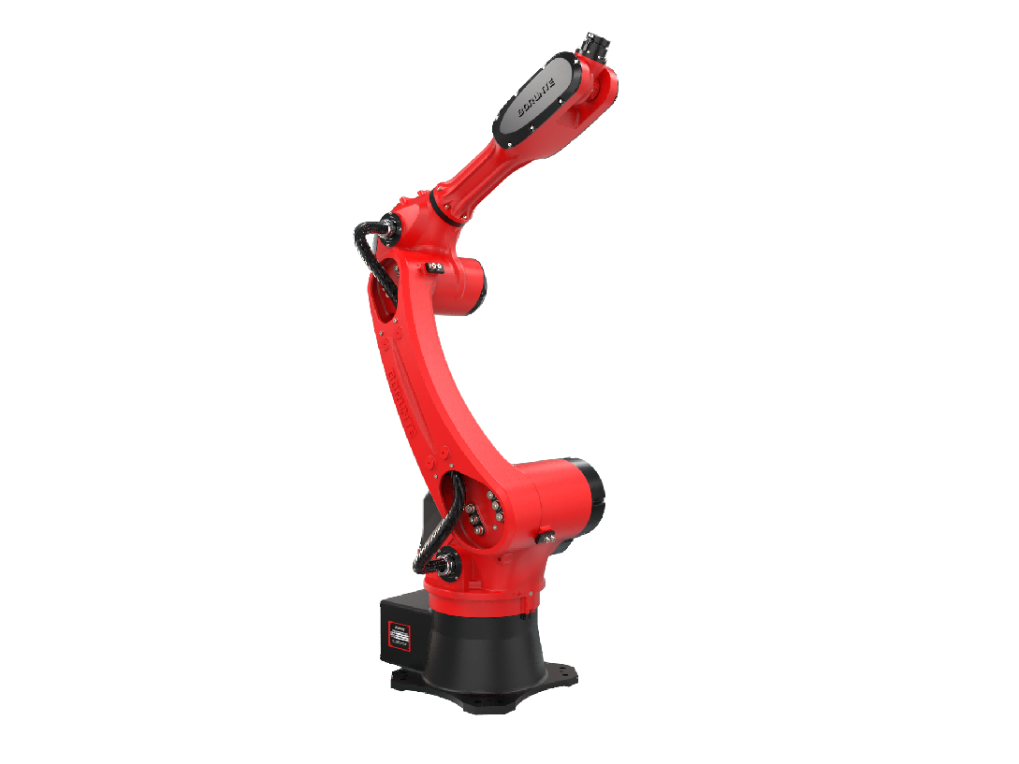

（Without further notice if specification and exterior have been changed because of improvement. Thanks for your understanding.）

- BRTIRUS1510A robot profile

1.1. Introduction of BRTIRUS1510A
BRTIRUS1510A is a six axis robot developed by BORUNTE for complex applications with multiple degrees of freedom, with a maximum load of 10kg and a 1587mm arm span. Adopting a lightweight arm design, the mechanical structure is compact and concise, and can perform flexible operations in a narrow workspace under high-speed motion. With six degrees of flexibility, it can freely handle scenarios such as loading and unloading, injection molding, die-casting, assembling, gluing, polishing, and testing. Easy to operate - use Huacheng control system. Suitable for injection molding machine: 200T-600T.
High IP code：IP54
High accuracy：repeated positioning accuracy: ±0.05mm

1.2. Application of BRTIRUS1510A
(1). welding (2). injection molding (3). stamping (4). loading and unloading, etc.

- BRTIRUS1510A robot specifications
Model |  |  | BRTIRUS1510A
Axes |  |  | 6 axis
Loading ability |  |  | 10kg
IP code |  |  | IP54
Repeated positioning accuracy |  |  | ±0.05mm
Maximum arm span |  |  | 1587mm
Weight |  |  | 152kg
Max speed | J1 |  | 190°/s |  |  | J2 |  |  | 173°/s
Max speed | J3 |  | 223°/s |  |  | J4 |  |  | 254°/s
Max speed | J5 |  | 270°/s |  |  | J6 |  |  | 342°/s
Motion range | J1 |  | ±165° |  |  | J2 |  |  | -95°/+70°
Motion range | J3 |  | -85°/+75° |  |  | J4 |  |  | ±180°
Motion range | J5 |  | ±115 |  |  | J6 |  |  | ±360°
Allowable torque | J4 | 32.8N*m |  | J5 | 32.8N*m |  |  |  | J6 | 17N*m
Allowable moment of inertia | J4 | 0.46kg*m² |  | J5 | 0.62kg*m² |  |  |  | J6 | 0.155kg*m²
Mounting environment | Operating temperature： 0℃~40℃  Best temperature：15℃~25℃  Relative humidity：20~80% RH（No condensation） |  |  |  |  |  |  | Mpa |  |  | 0.5~0.7MPa
Mounting environment |  |  |  |  |  |  |  | Power supply |  |  | 220V±10％ 50Hz/60Hz
Core components | Name |  | Operating system |  |  | Brand |  |  | BORUNTE
Core components |  |  | Casting body |  |  |  |  |  | BORUNTE
Core components |  |  | Servo motor |  |  |  |  |  | BORUNTE
Core components |  |  | Reducer |  |  |  |  |  | BORUNTE
Core components |  |  | Electrical component |  |  |  |  |  | BORUNTE
Oil content | J1 |  | 900ML | J2 |  |  | 800ML |  |  | J3 |  | 400ML
Oil content | J4 |  | 50ML | J5 |  |  | / |  |  | J6 |  | /
Vulnerable parts | J4 timing belt |  | MBT233080303 Timing belt 3M-08 bandwidth - 89 teeth
Vulnerable parts | J5 timing belt |  | MBT233080301 Timing belt 3M-08 bandwidth - 117 teeth
Robot accompany materials | USB

The rated power, specifications, external dimensions, etc. of this product are subject to modification without prior notice.
Technical data and illustrations are for supply reference only and reserve the right to make changes.


